FREE ONLINE COMMUNITY REFEREE COURSE
Via Basketball NSW website, Officials, Become a Referee, Free Online Community Referee Course
OR use this link https://www.bnsw.com.au/officials/become-a-referee/
Under Free Online Community Referee Course heading
Select – Register Here For Free.
This takes you to Gameday and there is a Link showing.
Copy link and paste into your web browser.
Using BasketballConnect complete participant details & emergency contact then at bottom right select NEXT.
You should now be in section 2) Select Competitions; and be able to see BNSW Community Programs.
Tick event/program – player
Registration Division select Course Material
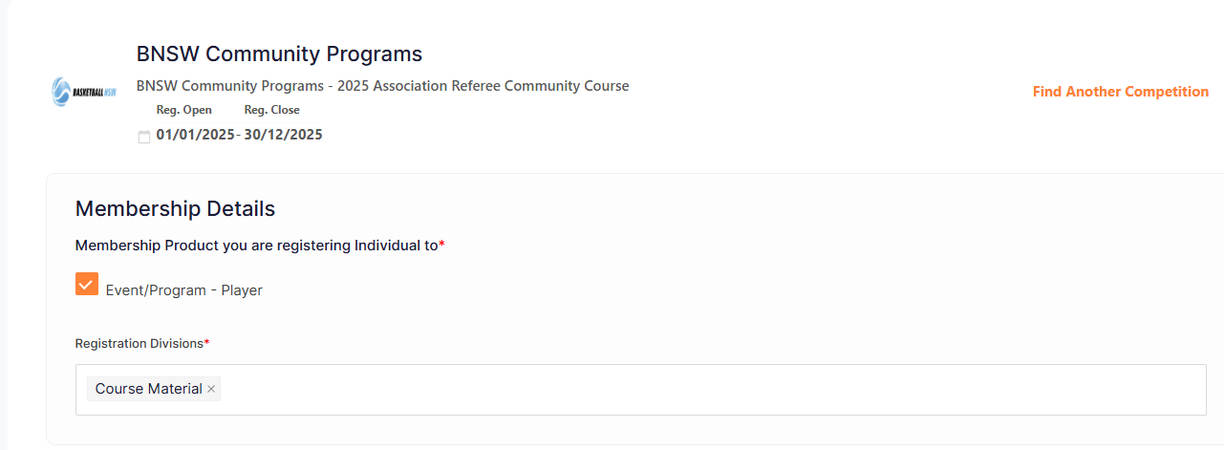
Scroll down, at bottom right select ADD COMPETITION AND MEMBERSHIP
You should now in in 3) Additional Information.
Compete Questions.
Scroll down, at bottom right select ADD COMPETION AND MEMBERSHIP
Dream Hoops is for donations – select No, sorry not at the moment; if not interested
Select from Participant and Parent Details.
On right hand side you should see YOUR ORDER with 0.00 payment due.
Tick – I have read and agree to T&C
Select CONTINUE
Select SUBMIT
Course Materials to be sent out every Friday.
Contact is Louis Brockwell.
If information not received email louis.brockwell@bnsw.com.au

